Whistleblower Bylaw

Sample Template - September 2020

Disclaimer – This sample template is intended to be used as a guide by municipalities to develop a bylaw. The content must be modified and formatted to suit the needs of the municipality.

FULL NAME OF MUNICIPALITY
BYLAW NO. _____________
A BYLAW TO ESTABLISH WHISTLEBLOWER

Short Title

- This bylaw may be cited as the “Whistleblower Bylaw”.

Purpose

- This Whistleblower Bylaw is designed to address disclosure and investigation of a wrongdoing and to protect the disclosing party from discriminatory action. Where the results of the investigation find reasonable grounds to indicate that a wrongdoing has occurred, the investigation findings shall be reported to the appropriate party with jurisdiction over the matter. The municipality will cooperate fully in any subsequent law enforcement investigation. The municipality’s own investigation may continue regardless of the status of any law enforcement investigation and may result in disciplinary action, regardless of the outcome of the law enforcement investigation.

The municipality will make every reasonable effort, including through legal processes, to pursue the recovery of financial, property, information or other losses from the wrongdoer or other appropriate sources.

- The council of the Municipality of _______________________________ fully supports whistleblowing and is committed to protecting whistleblowers, the important information they provide and more widely, the integrity of the whistleblowing process. All persons who are considering reporting concerns in good faith can be assured the concerns will be taken seriously, their identity will be protected and, as an employee of the municipality, they are protected from detrimental treatment, retaliation or employment harassment.

- The purpose of this bylaw is to:
  - establish additional mechanisms to ensure consistent and systematic processes are in place for the prevention, detection, reporting and investigation of any suspected act of wrongdoing; and
  - establish specific whistleblower process responsibilities and protection from reprisal.
Scope

- The scope of this bylaw is to:
  - provide a process for a wrongdoing committed by any employee, elected official or vendor;
  - provide for disclosure of wrongdoing made by any elected official or employee; and
  - protect a whistleblower from a discriminatory action.
- Nothing in this bylaw shall be interpreted to limit any right that any municipal employee may have under any other municipal bylaw or policy, any Act or law, to disclose information about wrongdoing to a lawful authority and/or to seek protection from, or redress for, damages resulting from a discriminatory action as a result of such disclosure.

Definitions

- For the purpose of this bylaw, the following terms and words shall have the following meanings:
  - Disclosure means a complaint submitted by an employee alleging action of wrongdoing on the part of any employee, vendor or elected official or alleging that any person has been a victim of discriminatory action for disclosing a wrongdoing or participating in an investigation of a wrongdoing.

  - Discriminatory Action means any action or threat of action by an employer that does or would adversely affect an employee with respect to any terms or conditions of employment or opportunity for promotion, and includes termination, layoff, suspension, demotion or transfer of an employee, discontinuation or elimination of a job, change of a job location, reduction in wages, change in hours of work, reprimand, coercion, intimidation or the imposition of any discipline or other penalty but does not include:
    - any reassignment of duties for the reasons set out in section 2-41 or subsection
2-49(4); or
    - any other prescribed action.
  - Designate means the person appointed by council and he/she could be the administrator (dependant on the size of municipality, choose what suits the municipality).
    - External Designate means an external third party service provider.
    - Internal Designate means an internal person under the direction of the municipality. This internal designate may be the:
      - Municipal Solicitor;
      - Chief Financial Officer;
      - Director of Human Resources; or
      - Administrator.
  - Alternative Designate means the person appointed by council as the designate in the situation where the administrator or the appointed designate is the alleged wrongdoer.

  - Elected Official means the mayor/reeve or a councillor of the (full name of municipality).

  - Employee means a person receiving or entitled to wages; a person whom an employer permits, directly or indirectly, to perform work or services normally performed by an employee; a person being trained by an employer for the employer’s business; a person on an employment leave from employment with an employer; and a deceased person who, at the relevant time, was a person described in any of the above, but does not include a person engaged in a prescribed activity.
  - Employer means an employer as defined The Saskatchewan Employment Act.
  - Initial Screening means a type of interview that the designate would conduct to determine if the disclosure requires more information before the investigation process begins.
  - Investigator means a person appointed by council other than the designate, who carries out a formal inquiry or investigation of a wrongdoing and could be: (dependant on the size of municipality, choose what suits the municipality. You may need additional investigators.)
    - External Investigator means an external qualified, impartial professional, hired at the direction of council, who is not an employee or an elected official and has no personal affiliation with any employee, vendor or elected official.
    - Internal Investigator means the person appointed by the council to conduct an investigation, at the direction of the designate, arising from a disclosure.

  - Investigation Report means a confidential report after an investigation of a disclosure containing the findings, the reasons for those findings and any recommendations.

  - Municipality means the (full name of municipality).

  - Reprisal means any of the following measures taken by any person against an employee of a municipality:
    - a dismissal, layoff, suspension, demotion or transfer, discontinuation or elimination of a job, change of a job location, reduction in wages, change in hours of work or reprimand;
    - any measure, other than one mentioned in subclause i), that adversely affects municipal employee’s employment or working conditions or hinders the performance of that person’s duties;
    - a threat to take any of the measures referred to in subclauses i) to ii); and
    - a discriminatory action as defined in The Saskatchewan Employment Act.

  - Vendor means any person, corporation or firm with whom the municipality has a contract for the procurement of goods or services.

  - Whistleblower means a council member or employee who makes a disclosure of a wrongdoing as herein defined, in an attempt to expose and end the wrongdoing.

  - Wrongdoing includes any of the following committed by a municipal council, council member or municipal employee:
    - a contravention of any federal or provincial legislation;
    - a contravention of any municipal bylaw or policy;
    - contraventions of the code of ethics, rules of conduct and procedures applicable to every member of council imposed by this and any other Act and by council;
    - acts or omission that creates:
      - a substantial and specific danger to life, health, or safety; or
      - a substantial and specific danger to the environment;
    - gross mismanagement of public funds or a public asset; and
    - knowingly directing or counselling someone to commit a contravention, an act or an omission mentioned in subclause i) to v).

Responsibilities

- The administrator is responsible for:
  - the overall administration of this bylaw;
  - making recommendations to council for appointments and then posting name(s) of the designate/alternate designate and investigator;
  - developing and implementing policies to administer this bylaw; and
  - a communication strategy for council approval.
- The designate or alternate designate is responsible for:
  - receiving disclosures and conducting initial screening;
  - immediately reporting to council if disclosure could affect the municipality’s financial position, internal controls or exposure to liability conducting initial screening;
  - determining and notifying the investigator if an investigation is warranted;
  - notifying the whistleblower if no investigation is warranted;
  - reviewing and reporting to council all disclosures and investigations; and
  - contacting the solicitor and/or law enforcement if a criminal act is reported and is directed by council resolution to do so.

- The investigator is responsible for:
  - receiving the initial screening from designate or alternate designate (this will result in investigator taking on a larger role working with council);
  - notifying the whistleblower that the investigation will be proceeding within 10 days of initial screening;
  - investigating in a confidential manner to determine if there are reasonable grounds of a wrongdoing;
  - notifying the wrongdoer of the opportunity to respond to the disclosure;
  - filing the report with designate or council, depending on who the wrongdoer is; and
  - assisting if more investigations are needed.
- Employees and council members are expected to be familiar with the provisions of this bylaw, policies and communication strategies and disclose any suspected wrongdoing as soon as possible.

Process and Procedures

- Disclosures of wrongdoing
Whistleblowers have a responsibility to disclose a wrongdoing to the designate. Where urgent action is required to prevent imminent wrongdoing, a written disclosure is not required and the disclosure may be made verbally to any designate.
Disclosure of the wrongdoing should be in writing, using the form in “Schedule A” with as much detail as possible, including:
  - the name of the whistleblower;
  - the position of the whistleblower with the municipality;
  - the name and position of each employee, elected official or vendor against who a disclosure is made;
  - the specific nature of the alleged wrongdoing;
  - the specific date or dates of the alleged wrongdoing;
  - a statement as to the information or evidence upon which the disclosure is based; and
  - any other information or evidence that the whistleblower believes may be relevant or material to an investigation of the disclosure.

- File a report of wrongdoing
Disclosures shall be received by the:
  - designate in the case of a disclosure relating to an employee other than the administrator; or
  - alternate designate in the case of the disclosure regarding the administrator or designate.

The designate or alternate designate has primary responsibility for the initial screening of disclosures. They will perform an initial screening and report to council. The designate will determine if an investigation is warranted and the alleged wrongdoer will be contacted if there is an investigation. These determinations will not be influenced by the position or length of service of the employee(s) or elected official accused of the wrongdoing, or that of the employee making the disclosure.

Where a whistleblower discloses the wrongdoing verbally, the designate receiving the disclosure must document the discussion, confirm its accuracy with the whistleblower, and promptly forward the disclosure in confidence to the administrator.
Whistleblowers may choose to remain anonymous when making a disclosure. However, investigation may not be possible unless the source of the information is identifiable. The whistleblower may decide to submit a disclosure to the designate on an anonymous basis based on the circumstances, including the seriousness of the issues raised, the credibility of the concern, and the likelihood of confirming the report from other sources.

If a disclosure of a wrongdoing involves the administrator, the alternate designate shall have primary responsibility for the initial screening of the disclosure and will be responsible to promptly report to council and appoint an investigator.

- Investigations if alleged wrongdoing involves financial position
  - If upon initial screening, it appears that the disclosure could materially affect the financial position of the municipality, the integrity of the municipal system of internal controls or the municipality’s exposure to liability, the designate or alternate designate shall immediately advise the council.
  - The designate has the discretion to determine if an investigation and/or law enforcement is required.
  - In circumstances where it appears that a criminal act allegedly occurred, the designate or alternate designate will report the matter to council. Then, by resolution, on the advice received from the municipal solicitor, be reported to the appropriate law enforcement agency.
  - If an investigation proceeds, and within 10 working days of an initial screening being received, the investigator will respond in writing to the whistleblower acknowledging that the disclosures of the alleged wrongdoing have been received and an investigation will proceed.
  - If no investigation is warranted, and no later than 10 working days of an initial screening being received, the designate or alternate designate will respond in writing to the whistleblower acknowledging that the disclosure of the wrongdoing has been received and that no investigation is warranted.
  - The individual(s) accused of the wrongdoing will be given an opportunity to respond to the disclosure made. The investigator will consider the response and may choose to investigate further. An exception to this is if extenuating circumstances exist that warrant immediate action, such as to prevent imminent wrongdoing.
  - If a disclosure of wrongdoing against an employee is substantiated by investigation, the employee may be subject to disciplinary action as described in section 17.
- Investigations if alleged wrongdoing does not affect financial position
  - The designate or alternate designate shall decide if an investigation is needed after receipt of initial screening.
  - The designate or alternate designate forwards the initial screening to the appointed investigator.
  - The investigator will, within 10 working days of an initial screening being received, respond in writing to the whistleblower acknowledging that the disclosure of the alleged wrongdoing has been received and an investigation will be proceeding.
  - If no investigation is warranted, within 10 working days of an initial screening being received, the alternate designate will respond in writing to the whistleblower acknowledging that the disclosure of the wrongdoing has been received and no investigation is warranted.
  - If an investigation proceeds, the investigator will document the results of each investigation in a confidential investigation report and provide that to council.
  - A person under investigation shall be provided with the essential particulars of the investigation report and shall have an opportunity to respond to the investigator before any decision on disciplinary action is made.
  - Where causes of the wrongdoing can be identified, the designate or alternate designate will submit the investigation report during a closed session of a council meeting, then assign responsibility to ensure steps are taken to address the causes and mitigate the risk of further occurrences.
  - If a disclosure of an alleged wrongdoing is substantiated by investigation, the wrongdoer may ask for more information.
  - When reviewing the investigation report in a closed session and the administrator is the alleged wrongdoer, the council can request the administrator leave the meeting.
  - After reviewing an investigation report, council may take disciplinary action as described in section 17:
  - If council concurs that the administrator or designate has committed the wrongdoing, council may take disciplinary action that is not inconsistent with
The Municipalities Act, this bylaw, and the Code of Ethics Bylaw.

Disciplinary Action

- Every person who contravenes this bylaw is guilty of an offence and liable on summary conviction in accordance with section 114.1 of The Municipalities Act.

Confidentiality

- Anyone involved in the investigation of a disclosure will make every reasonable effort to maintain confidentiality.

Investigations will be carried out on a “need to know” basis and in a manner that limits revealing details of the disclosure and information obtained in the course of the investigation. Information about a disclosure of a wrongdoing will only be revealed to those responsible for investigating or addressing the disclosure, or as necessary, to conduct a thorough investigation. Information regarding disclosures and investigations will also be provided to the administrator. If the disclosure is regarding the administrator, the information will go to the designate.
Confidentiality extends to all records relating to disclosures, including, but not limited to, records relating to meetings, interviews, and investigation results. Personal information, including the identity of the whistleblower, will only be disclosed as required or permitted by law. Although all reasonable steps will be taken to protect the identity of the whistleblower, information collected and retained may be required to be released by law, including those requirements pursuant to privacy legislation, court proceedings, arbitration, or other legal proceedings.

Individuals making a disclosure, investigators, witnesses and individuals against whom a disclosure has been made are expected to maintain confidentiality. Breaches of confidentiality may be regarded as wrongdoing, and may be subject to disciplinary action consistent with section 17 of this bylaw.

Whistleblower Protection

- A whistleblower shall be protected from any form of discriminatory action, defined in subsection 7(k), against council or an employee who disclosed a wrongdoing in good faith, or who acted as a witness or otherwise participated in an investigation in good faith. It is considered a wrongdoing in accordance with this bylaw.

If an employee believes that he or she has been the subject of discriminatory action, that employee may file a disclosure of the alleged discriminatory action to the designate who will ensure that the alleged discriminatory action is appropriately investigated. Where an investigation substantiates a discriminatory action, the administrator and/or the designate will be informed, and any individual responsible will be subject to disciplinary action consistent with section 17 where appropriate.

PART VII
COMING INTO FORCE

This bylaw shall come into effect on the day of its final passing.
____________________________________
Reeve/Mayor
{Seal}
____________________________________
Administrator
Read a third time and adopted
this ____ day of ___________.

_________________________
Administrator

(SAMPLE ONLY: Municipalities may develop their own form.)

Schedule A
Disclosure of Wrongdoing

Please note that knowingly signing a false affidavit may expose you to prosecution under
the Criminal Code of Canada.

I __________________________________ of________________________________________,
(First and Last Name) (Full Mailing Address)
do solemnly swear/affirm and declare that the following contents of this statement are true and correct and hereby request the designate of the _________________________________ (Full Name of Municipality) to ________________________________________ (look into/conduct an investigation/follow-up on) whether or not the following individuals of the _________________________________ (Full Name of Municipality) has (have) committed a wrongdoing in accordance with the Whistleblower Bylaw:
_________________________________________________________________________________(Individual(s) or Employees, Elected Officials or Vendor Names)
I have reasonable and probable grounds to believe that the above individual(s) has (have) committed a wrongdoing by reason of the following:
- description of wrongdoing;
- insert date(s), time and location of wrongdoing;
- provide the particulars and names of all persons involved, and of all witnesses;
- provide contact information for all people listed (if known); and
- any additional information can be attached. If more space is required, please attach additional pages as needed.
____________________________________________________________________________
____________________________________________________________________________
____________________________________________________________________________
____________________________________________________________________________
____________________________________________________________________________
____________________________________________________________________________

__________________________
Printed Name
For Office Use Only
_____________________
(Date filed)
_____________________
(Signature of ___________ (i.e. Municipal Administrator, City Clerk, or other applicable position pursuant to subsection 4(a) of bylaw)

__________________________
(Signature of Whistleblower)

__________________________
(Date Signed)

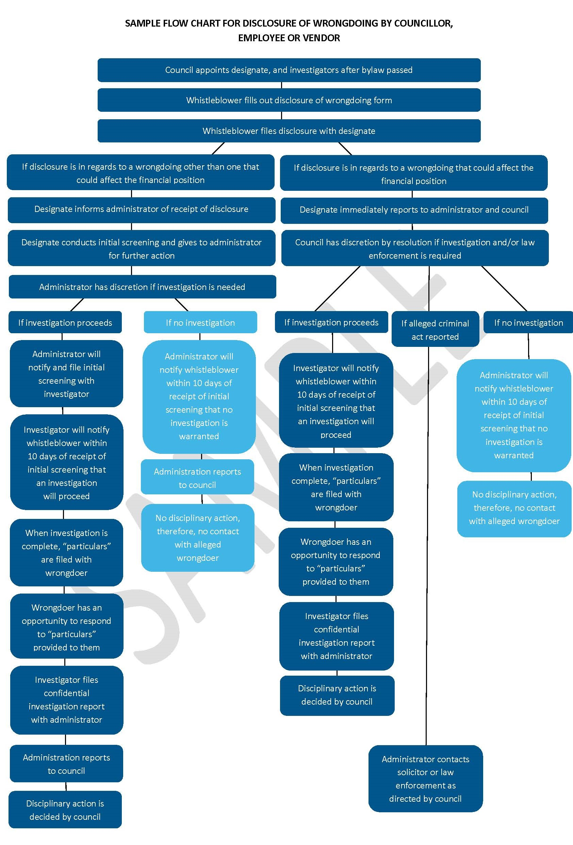
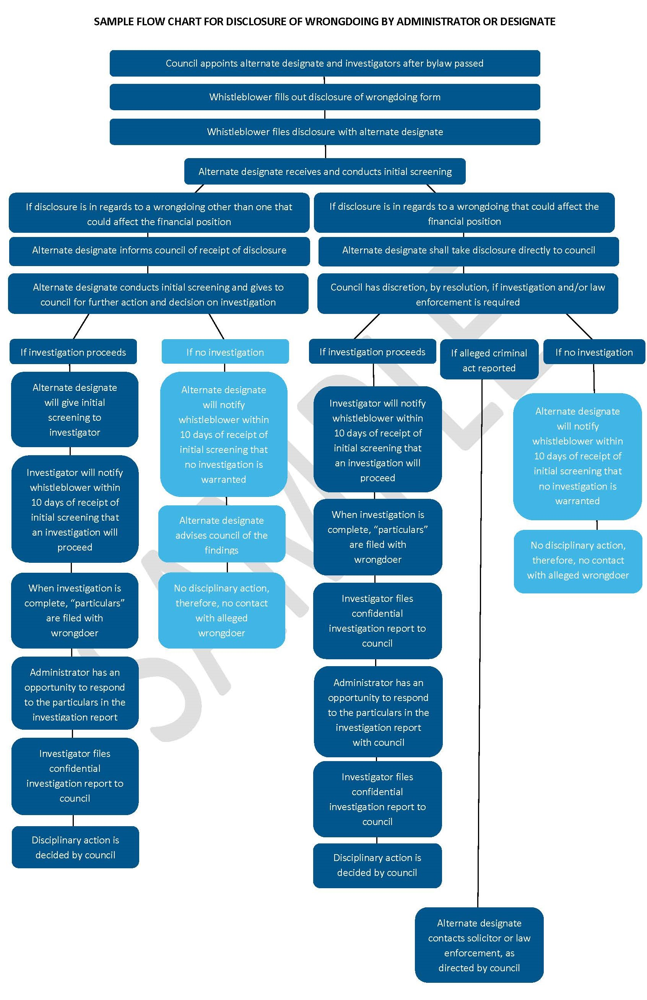

Resolution required to appoint a designate.
Resolution required to appoint an investigator.
Administrator may want to reference The Public Interest Disclosure Act.

