Paying Child Support
What you need to know.

Did You Know?
If you have arrears in child support or have paid too much child support, the law in Canada says that the court will only waive those arrears or address overpayment in exceptional circumstances. This is because there is an obligation on child support payors to take steps to pay appropriate support.


What is child support and who is it for?
Parents are required to financially support their children, regardless of separation or divorce. Child support is intended to cover costs related to raising a child. The right to benefit from the support is the right of the child. Child support is not something parents can bargain away because it is not their support, it is the child’s.

You and your co-parent have a Financial Connection.
What does this mean?
You and your co-parent have obligations to each other in relation to child support. You are obligated to let your co-parent know andtake steps to pay support based on current income. This applies to both you and your co-parent if there is a shared or split parenting arrangement.

Why?
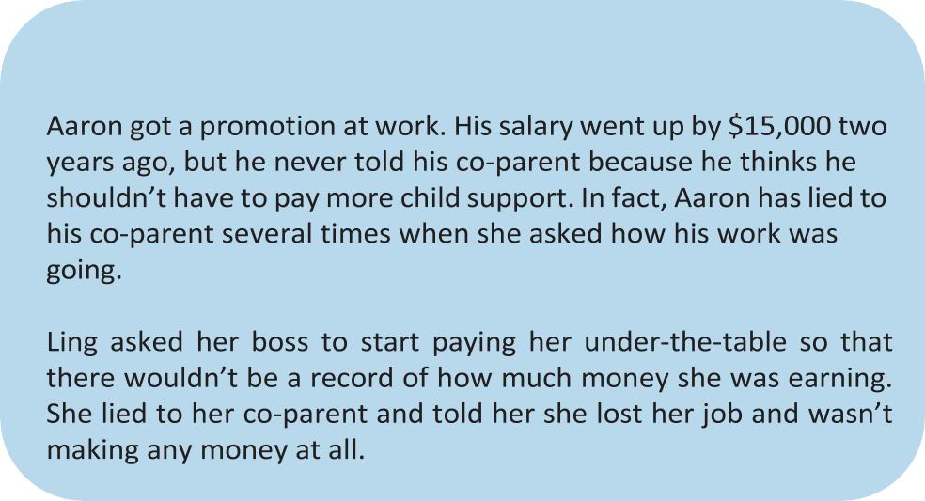
You and your co-parent have a right to know each other’s financial circumstances to establish or update child support. If you don’t tell your co-parent about income changes, this may be considered ‘blameworthy conduct.’ This means that you have put your interests above the child’s right to receive appropriate support. Blameworthy conduct is considered when seeking changes to ongoing and retroactive child support.
What might be considered ‘Blameworthy Conduct’?
If you want to go to court to change your support arrears or ask to be repaid for over-paid support, you will have to show the court why it is appropriate to make changes. If you wait years to try to get your support obligations updated, the court may not adjust your arrears or overpayment. This is because you did not take steps sooner even though you may not have earned as much money or paid more than you should have. When making this decision, the court will consider any blameworthy conduct.
Therefore, it is important to take timely steps to pay the correct amount of support.

FAMILY JUSTICE SERVICES OFFERS FREE SERVICES TO ASSIST WITH CHILD SUPPORT MATTERS

Maintenance Enforcement Office (MEO)


The MEO assists with the collection of support payments. MEO can take steps to enforce support orders including garnishing wages and intercepting tax refunds. MEO is not just for parents who are having problems receiving support, it can also help make sure both parties have a legal record of the payments being made for child support. This can be helpful in the event a record of payments is needed in the future to assist with a court application. For more information contact the MEO at 1-866-229-9712 or email meoinquiry@gov.sk.ca.

Child Support Service
This program helps families ensure an appropriate level of support is paid for their children. Parents can apply for an initial child support calculation if they don’t have an agreement or court order in place. The Service also recalculates existing child support amounts to reflect changes in income. The service is a no-cost option and families are not burdened with the time and expense of pursuing child support or adjustments through the court.

To determine if you are eligible for a child support calculation or recalculation, you can find information online at Child Support Service | Child Support | Government of Saskatchewan, or contact by phone at 1-833-825-1445, or email childsupportservice@gov.sk.ca.

TIPS/SUMMARY
- DISCLOSE: Having a child support obligation means that your co-parent is entitled to know details about your financial situation until your children are no longer dependent. Therefore, keep your co-parent in the loop – be honest and transparent if your income changes.
- Remember that the obligation to disclose changes applies to both parents if there is a shared or split parenting arrangement.
- If your income changes and you and your co-parent don’t agree on what the appropriate support should be, don’t wait – take steps to update your support obligations.
- Pay support based on your income – you can check on your support obligations by using the Child Support Look Up table: 2025 child support table look-up (justice.gc.ca)
- Remember that the law in Canada says that there is a presumption that arrears and overpayments cannot be waived or set aside if you don’t take steps to try and deal with them in a timely fashion.

For more information regarding child support and family law, you can contact the Family Law Information Centre at
1-888-218-2822 or email familylaw@gov.sk.ca.

