Our Mining Industry

Saskatchewan mineral sales totaled $6.1 billion in 2020. Natural Resources Canada (NRCan) estimates that Saskatchewan accounted for 14% of national sales value, third highest in Canada.
The province is the largest potash producer in the world, accounting for approximately one-third of total production in 2019, and hosting over half of the globe’s potash reserves. Saskatchewan is also one of the world’s largest producers of uranium, with the Athabasca Basin containing the largest high-grade uranium deposits in the world.
Saskatchewan is Canada’s third-largest producer of coal, producing an average of 10 million tonnes per year.
The province is also home to one of the world’s largest fields of diamond-bearing kimberlite. Star Diamond Corp., in partnership with Rio Tinto, is currently evaluating the Star-Orion South project, which is estimated to contain more than 66 million carats. Recent discoveries in the northeast part of the province have highlighted Saskatchewan's potential for diamonds elsewhere.
Saskatchewan has large underexplored areas with high gold potential. The Seabee Operation produced 81,686 ounces of gold in 2020.
First in Canada and Third in the world for mining investment attractiveness accourding.
Fraser Institute, Survey of Mining Companies, 2020

In addition, the province has deposits of copper, zinc, nickel, rare earth minerals and platinum group metals as well as various industrial minerals including sodium sulphate and salt. Download the Resource Map of Saskatchewan for details on where these minerals are located.

Major Mining Companies Operating in Saskatchewan
- Nutrien
- Mosaic Company
- BHP Billiton Canada Inc.
- K+S Potash Canada
- ORANO Canada
- Cameco
- Rio Tinto
- Yancoal
- SSR Mining
- Compass Minerals
- North Atlantic Potash
- Western Potash
- Gensource
- Foran Mining
- NexGen Energy
- Fission Uranium

Fast Facts

Total operating mines (2020): 20, including potash, uranium, gold, coal, sodium sulphate, salt and clay
GDP (2020): Minerals and petroleum contribute 25.8% of total provincial GDP
Total mineral sales value (2020): $6.1 billion
Value of potash sales (2020): $5.56 billion
Exploration expenditures (2020 est.): $242 million

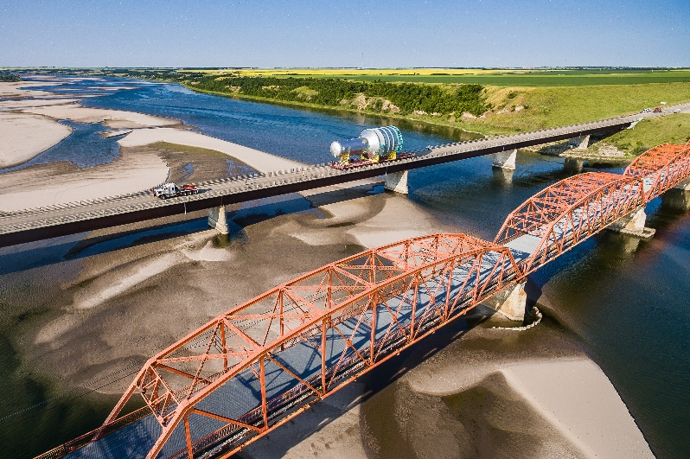

Current Industry Activities
From 2008 to 2018, the mining sector has invested $168 billion into capital projects in Saskatchewan. Over the last year, there have been significant announcements of investment in this sector including BHP’s approval of $7.5B in capital expenditures for the Jansen potash project and the Government of
Saskatchewan announced $31 million in funding
for the construction of a REE processing facility in
Saskatoon to be operated by the Saskatchewan
Research Council. While there continues to be long-term opportunities in supplying the mining industry in Saskatchewan, newcomers will need to understand current market conditions and provide additional value or solutions to compete with existing suppliers.

In addition to the significant ongoing mining operations and recent announcements in the province, there are several mining projects currently under different stages of evaluation.

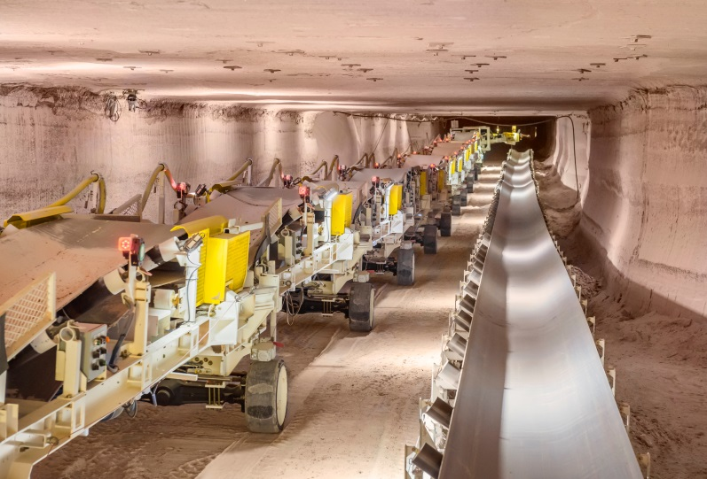
Supply Chain Opportunities
Opportunities for suppliers exist in both ongoing mining operations as well as new mine development. Examples of the types of equipment, goods and services required for standard operations and development are listed below:

Operating Mines:
- Chemicals and reagents
- Autonomous and remotely operated equipment
- Fuels and lubes
- De-dusting oil for potash
- Mobile equipment - trucks, dozers, front-end loaders
- Underground conveyor belting
- Bearings, seals and power transmission parts
- Electrical consumables such as breakers, fuses, switches and fixtures
- Pipes, valves and related fittings, i.e. PVC, steel and copper
- Boilers, piping, forged components
- Electronics and instrumentation
- Logistics, handling and storage
- Reagents and environment
- Bulk cement, explosives
- Diesel fuel, propane
- Maintenance parts – mobile equipment
- Computers and telecommunication
- General service

Site Services:

- Water
- Waste disposal
- Catering
- Camp accommodation
- Janitorial services
- Pest control
- Onsite security
- Onsite medical
- Transportation
- Internet and phone
- Storage shelters

Key manufactured goods for new mine development:

- Pumps and piping
- Valves and fittings
- Concrete
- Electrical
- Steel and fabrication
- Equipment

Surface Construction:

- Mill/product storage/
flotation buildings
- Cyclones
- Grinding equipment
- Scrubbers
- Pumps and piping
- Dryers
- Thickeners
- Tanks and storage bins
- Conveyors
- Bucket elevators
- Boilers
- Centrifuges
- Overhead cranes
- Compressors
- Fire protection systems
- Process control equipment
- Process chemicals
- HVAC equipment
- Agitators
- Belt scales
- Transformers
- Switch gears

Underground Construction:

Walking/drill rigs and drill bits
Ultrasound measurement equipment
Hoist rope/wire rope
Winches
Pumps
Electrical equipment
Hydraulic motors
Conveyors and components
Fans
Scoop trams
Limit switches
Cranes
Crushers
Screens
Rock drill lifts
Instrumentation
Load and hauling machinery
Raise bore systems
Specialized mine vehicles
Rock tools
Explosives and suppliers
Rock drills

Events and Resources

Saskatchewan Mining Supply Chain Forum
This annual event provides a venue for mining project, procurement and operations personnel to meet with manufacturing, equipment and service companies to discuss opportunities in the mining supply chain.
The forum attracts over 900 participants who represent mining, engineering and supply chain companies.
Forum attendees hear presentations delivered by organizations such as Nutrien, BHP, Orano, Cameco, Mosaic and SSR. The forum tradeshow also provides attendees with the opportunity to network and connect with mining and engineering companies from across the province.
How to Successfully Access the Mining Supply Chain
This guide provides key information to Saskatchewan manufacturers interested in understanding the potash and uranium industries. The guide describes opportunities and the process of becoming a successful preferred supplier. The guide also provides insight into the characteristics mining companies look for in suppliers.
www.publications.gov.sk.ca/details.cfm?p=81697

Potash Mining Supply Chain Requirement Guide
This report provides information on the types of goods and services required to support the development and operation of both a conventional and a solution mine. It follows through lifecycle stages such as exploration and resource evaluation, through to closure, reclamation and monitoring. www.publications.gov.sk.ca/details.cfm?p=81699

Uranium Mining Supply Chain Requirement Guide
This guide outlines the quantity, value and scheduling of supplies and services purchased by Saskatchewan’s uranium mining project owners and/or operators to assist with the development, operation, maintenance, decommission and close out of projects. www.publications.gov.sk.ca/details.cfm?p=81698

Saskatchewan Manufacturers Guide
This online database lists a variety of manufacturers in Saskatchewan, searchable by industry, product or location. www.economy.gov.sk.ca/mfgguide

Services We Provide
- Information regarding general supply chain opportunities in the mining industry
- Business-to-business support connecting suppliers to buyers
- Targeted industry events linking companies to current supply chain opportunities
- Resources and support for companies interested in investing in Saskatchewan

For more information, contact:

Michele Grella
Prospect Development Manager
Saskatchewan Ministry of Trade and Export Development
219 Robin Crescent
Saskatoon, SK S7L 6M8
Phone: (306) 933-5751
Email: michele.grella@gov.sk.ca

For additional information, please visit:
- Saskatchewan Ministry of Trade and Export Development
saskatchewan.ca
- Saskatchewan Industrial and Mining Suppliers Association (SIMSA) simsa.ca
- Saskatchewan Mining Association (SMA)
saskmining.ca
- Square One, Saskatchewan’s Business Resource Centre squareonesask.ca

